CONSULTARE INC.

COMPANY MANUAL

Welcome to Consultare Incorporated!

Consultare Inc. is a US based company that provides regulatory compliance consulting services to manufacturers, distributors and importers of foods, beverages, dietary supplements, drugs, cosmetics, medical devices, or electronic products.

Our Mission is to support every company’s regulatory and certification compliance needs and to develop all necessary programs to assist their quality assurance and food safety team.

We believe in your skills and expertise in helping us fulfill our goals and achieve our mission. You are an important part of this process; your performance will directly influence our Company's stability and growth.

We are glad you are a part of Consultare Inc. and we hope you will find your performance challenging and rewarding.

Contents
PART 1: ABOUT US 4
1.1 About this Manual 4
1.2 Purpose of this Manual 4
1.3 Changes to the Policy 4
1.4 Virtual Assistant Forms 4
PART 2: EMPLOYMENT TERMS 5
2.1 Employment Applications 5
2.2 Types of Virtual Assistants 5
2.3 Recruitment 5
2.4 Internal Training School 5
2.5 Learning Management System 6
8
PART 3: TIMEKEEPING AND PAYROLL 8
3.1 Timekeeping 8
3.2 Payday 9
3.3. Deductions 9
3.4 Royalty and Commission 10
3.5 Sales and Marketing Incentives 10
3.7 Performance Reviews 11
PART 4: POLICIES 12
4.1 Virtual Office Policy 12
4.2 Email Management Policy 12
4.3 Holidays 12
4.4 Crisis Management Policy 13
PART 5: ON-THE-JOB Training 27
On the Job Training Procedure Error! Bookmark not defined.

PART 1: ABOUT US

About this Manual

This Virtual Assistant Manual contains information about the employment policies and procedures of the Company. We expect each Virtual Assistant to read carefully, as it is a valuable reference for understanding your job and the Company.
The policies outlined in this Virtual Assistant Manual should be regarded as management guidelines only, which is a developing business will require changes from time to time. The Company retains the right to make decisions involving employment to complete its task in a manner that is beneficial to the Virtual Assistant and the Company.
This Virtual Assistant Manual supersedes and replaces any and all prior Virtual Assistant Manual and any inconsistent verbal or written policy statements. The Company reserves the right to modify its policies and procedures at any time.

Purpose of this Manual
    - To clearly present the company’s policies, procedures, rules, and regulations.
    - To treat all the Virtual Assistants equally.
    - To inform all the Virtual Assistants about their rights.
    - To promote a productive and positive work environment.
    - To protect the company from any lawsuits.

Changes to the Policy

We reserve the right to change, cancel, suspend, or dispute, with or without warning on all or any part of these policies, rules, regulations, procedures, and benefits at any instance. However, Virtual Assistants will be informed if any changes have been made.
Changes will be effective on the dates decided by the company. When the changes take effect, previous policies will be voided.

Virtual Assistant Forms

The Virtual Assistants at Consultare needed to fill out the following forms:
1.4.1 Virtual Assistant Manual acknowledgment form
The Virtual Assistant Manual contains information, rules, regulations, wages, and other important company guidelines. This is to verify that you understand Consultare policies.
1.4.2 Leave Forms
These forms should be filled out by the Virtual Assistants in case they cannot report on their performance. It includes Sick leave, Emergency leave, Vacation leave, Maternity and Paternity leave, PTO, and Holiday leave. This form is available through Google form.
1.4.3 Other Forms
Forms that are required depending on the procedure as stated in this Manual

PART 2: EMPLOYMENT TERMS

2.1 Employment Applications
The company depends on the accurateness of information through employment application and the data provided by the candidates during the hiring process thus, any falsifications or misrepresentations may result in prohibiting the candidate from entering the company. If the candidate has been employed, termination of employment may be considered.

2.2 Types of Virtual Assistants

INTRODUCTORY PERIOD: Full-time and part-time regular Virtual Assistants of the Company are on an introductory period during their first 90 days of employment.
2.2.1 Full- time Virtual Assistants perform at least 8 hours per day or 40 hours per week, Monday to Friday.
2.2.3 OJT Virtual Assistant (Crossover) perform at least 4-8 hours a day or 20- 30 hours per week, Monday to Friday.
2.2.4 Freelancer performs task on an hourly basis and/or on writing and creating images for Program Form Lesson Bundle can be a Document/Project/Task in a given period of time.

2.3 Recruitment

The recruitment team gathers applicants thru any hiring media. Resumes and CV’s will be evaluated based on experience and skills.

2.3.1 Qualified applicants will receive an email invitation to attend the Company Orientation.
2.3.2 Attendance and participation in a Company Orientation is required.
2.3.3 Upon submission of the email format after the Orientation a final interview will be scheduled.
2.3.4 The qualified applicant passed all interviews an email notification will be sent together with the following requirements:
2.3.4.1 Valid ID
2.3.4.2 A stable internet connection with at least 5mbps.
2.3.4.3 A personal computer or laptop with an i3 processor and at least 4GB RAM.
2.3.4.4 A backup internet connection can be mobile data or prepaid wi-fi.
2.3.5 Onboarding training will be scheduled by the HR department and will be enrolled in the Internal Training School.
2.3.5.1 All trainees will undergo a 30-, 60- and 90-days training period.
2.3.5.2 Trainees who performed well during the first evaluation after 15 days of training
period will be recommended to L1 level and fast track their 90-day training period.

2.4 Internal Training School

The Internal Training School is the training department that handles new VA. Monitoring Training Progress conducts daily training activities to equip the new VA prior to endorsement to the department assigned.

2.4.1 Training Plan
2.4.1.1 A 15 days daily training activity. (Refer to Training Plan)
2.4.1.2 The 6 days training period is covered by Internal Training School.
Topics are Company Onboarding, Email Etiquette, Citation, Document Control, PRP Dashboard, and PCQI Conversion.
2.4.1.2.1 An initial assessment will be done by the Trainor’s and mentors if VA is ready to be assigned in an account.
2.4.1.3 On the 7th day the VA will be assigned to an Account and with shadow training to the assigned team and continuously attend ITS until the 15th day.
2.4.1.3.1 A second assessment will be done by the Team Lead mentor.
2.4.1.3.2 If Virtual Assistant needs re-training, he/she will continue in the ITS for another 3 days and training will focus on the needs for improvement as recommended by the Team Lead.
2.4.1.3.3 Additional topics maybe discussed during the 15days training period if the need arises.

2.4.2 Training records
2.4.2.1 LMS Certificates - the trainee will email their certificate to ITS and HR.
2.4.2.2 PCQI Conversion and Customization – will be evaluated and reviewed.
2.4.2.3 Comprehension Quiz from ITS will be emailed for topics not covered in the LMS
Academy.
2.4.2.4 An ITS evaluation form is filled up for the day-to-day activities and rating during the 15days training.

2.4.3 Trainee
2.4.3.2 Evaluation – they will be evaluated based on performance and output on their assigned Account until 90 days.
2.4.3.3 Retraining – they will be re-train on some topics that need improvement.

2.5 Learning Management System

2.5.1. Freelance Writer
2.5.1.1. All interested applicants will receive a Pre-Test Assignment and will be given 48 hours to finish the test.
2.5.1.2. Once the applicant finished the Pre-Test Assignment, onboarding will be scheduled and will be trained to create the PFL bundle and SOP template.
2.5.1.3. PFL Bundle (Lessons and Programs)
2.5.1.3.1. Once the freelance writer received the assigned topic, he/she will be given 7 to 10 days to submit the drafted bundle for initial review.
2.5.1.3.2. The initial review will be sent back within 24 hours for any revisions.
2.5.1.3.3. The freelance writer will be given 48 hours to submit the revised bundle for final approval.
2.5.1.3.4. The topic assigned to a freelance writer can only be revised a maximum of three times. After which, the assigned topic will be canceled.
2.5.1.4. SOP Template
2.5.1.4.1. Once the freelance writer received the assigned topic, he/she will be given 24 hours to 48 hours/topic to submit the drafted SOP for initial review.
2.5.1.4.2. The initial review will be sent back within 24 hours for any revisions.
2.5.1.4.3. The freelance writer will be given 24 hours to submit the revised SOP for final approval.
2.5.1.4.4. The topic assigned to a freelance writer can only be revised a maximum of three times. After which, the assigned topic will be cancelled.
2.5.1.5. Freelance writers are welcome to enter the VO LMS during working hours 10 PM to 6 AM(Monday-Friday) for the concerns and coaching.
2.5.1.6. Once the PFL bundle/SOP template is approved, it will be submitted to the Accounting Department for the payment process.
2.5.1.7. Payment is processed every 15th and 30th of the month.

2.5.2. Graphic Artist

2.5.2.1. All interested applicants will receive a sample assignment and will be given 24 hours to finish one image.
2.5.2.2. Once the artist finished the image, they will be onboarded as a “Graphic Artist” and go into the standards of the required image.
2.5.2.3. Once the Graphic artist received the assigned topic, he/she will be given 5 days to submit the drafted images for initial review.
2.5.2.3.1. Graphic artists are welcome to enter the VO LMS during working hours 9 PM to 5 AM(Monday-Friday) for queries and concerns.
2.5.2.4. The initial review will be sent back within 24 hours for any revisions.
2.5.2.5. Once the images are approved, it will proceed to accounting department for the payment process.
2.5.2.6. Payment is processed every 15th and 30th of the month.

2.5.3. Uploading of Lesson

2.5.3.1. The approved lesson bundle will be upload to PCQILMS Academy website along with the thumbnail.
2.5.3.2. The lesson bundle is reuploaded once the images added are approved.
2.5.3.3. All internal lessons shall be uploaded to Moodle. This includes presentations and all training conducted by Internal Training School.
2.5.3.4 All Quality Management System bundle lesson will be uploaded to PCQI Learning Management Academy site.

PART 3: TIMEKEEPING AND PAYROLL

3.1 Timekeeping

All Virtual Assistants must electronically or manually record their actual hours performed. If done virtually, use the Service Log which can be found at the PRP System, and if through manually, use an Excel file.

All Virtual Assistants subject to this policy are required to accurately record all time performed.

The work schedule is weekdays from Monday to Friday. All Virtual Assistants are required to complete their service logs before the weekends. “No service logs, no payroll” is strictly implemented.

3.1.1 Service Log
3.1.1.1 All Virtual Assistant must have a username and password in the PRP system.
3.1.1.2 All Virtual Assistant must update their logs on a daily and weekly basis.
3.1.1.3 All service log must be breakdown properly according to standard:
3.1.1.3.1 Service Log thru Services
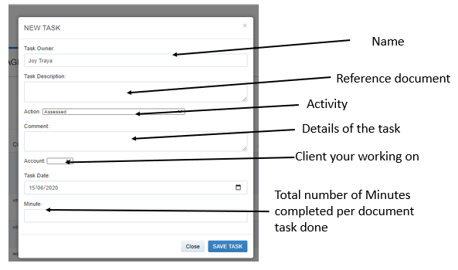
        - Service Log thru Mass Upload. Submit an excel file to IT personnel.

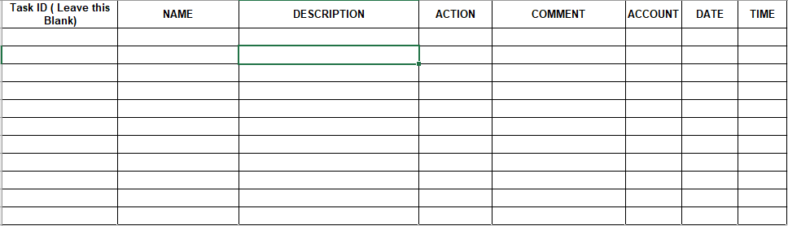

        - Service Log thru PMS – update projects time to time:
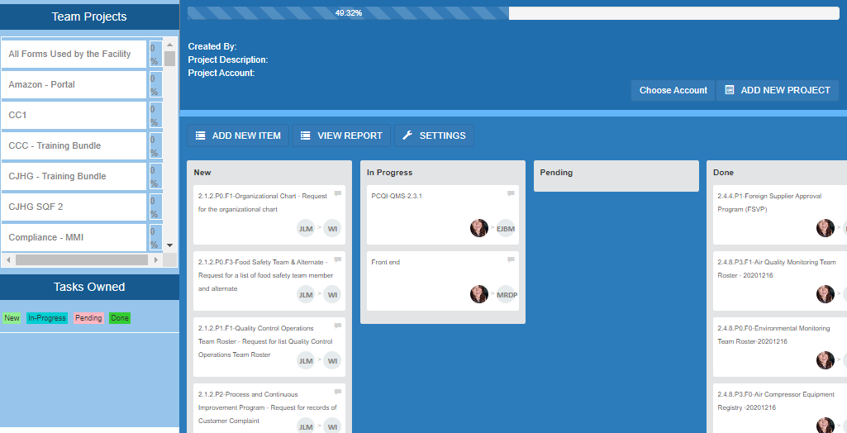
3.1.1.3.4. Service Log thru Mass Upload in the IT Portal.

3.2 Payday

Virtual Assistant salary is released every 15th and 30th of the month.

Payments are processed thru online pay portal such as Remitly, Paypal, Payoneer, World Remit or Transferwise remittance. If there are delays in the remittance concerns will be addressed by the Accountant and CFO.

3.2.1 Service logs and Time-proof must be updated during the cut-off day.
3.2.1.1 Payroll cut-off is between 8th-11th for the 15th pay and 21th - 25th for the 30th pay. Remitly posting is 4 banking days.
3.2.1.2 Accountant will prepare the payroll at least 3 days before the cut-off.
3.2.1.3 Once complete service logs will be reviewed along with PTO, absences and deductions.
3.2.1.4 Payroll will be submitted to Admin Manager for final review.
3.2.1.5 Once review is done it will be forwarded to the CFO for final approval and processing of pay.
3.2.1.5.1 Once pay is processed all references and charges will be recorded.
3.2.1.5.2 The CFO will forward the email to accounting for the remittance confirmation and will be forwarded to the VA.

3.2.2 “No PAY DUE” for those who will not update the logs within two cut-off period or 1 month. Service logs should be updated daily or weekly. Accounting will check their logs randomly.
Accounting will email to new Virtual Assistant the form to fill in their bank details.

Pay summary is forwarded thru email by accounting or you can also check the payroll system. If there is a discrepancy report it to Accounting immediately.

3.3. Deductions

All payroll deduction from Absences, Company Loans, Cash Advance, and Asset requisition.

3.3.1 If the allotted Paid Time Off is consumed before the year’s end and there is emergency leave and vacation leave that you need to attend to, your absences will be deducted within the pay period.
3.3.2 Cash bond from assets distributed by the Company.
3.3.2.1 A six-month cash bond upon the issuance of a laptop/Personal Computer/Headset will be deducted to the Virtual Assistant.
3.3.2.2 After a year the cash bond will be reimbursed if the Virtual Assistant remained loyal in the Company.
3.3.2.3 The eligibility of assets requisition is from Level 5 to Level 6.

3.3.3 Cash Advance/Company Loan/Computer Loan

3.3.3.1 The Virtual Assistant will submit a request for Asset/Cash Advance to immediate head for approval, must indicate the reason on the form or email.
3.3.3.2 The Cash advance will be approved if it is for medical or calamity purposes.
3.3.3.2.1 Medical emergencies should be within 1st degree of the family.
3.3.3.2.2 Calamity emergencies means acts of GOD
3.3.3.3 The Immediate head will send the CA to the accounting department once approved.
3.3.3.4 Accounting department will validate the cash advance and issue a Cash advance form and the summary of deductions, will send it to the VA to be signed by them and send it back to the Accounting department for documentation.
3.3.3.5 Once signed by the Virtual assistant, the accounting department will send the request to the Finance Director for processing.
3.3.3.6 Please take note that the Cash Advance amount is subject to approval by the Finance director depending on his status in the company.
3.3.3.7 Upon receiving the cash advance, VA should submit the proof of payment of his medical expenses for documentation
3.3.3.8 The Virtual Assistant will receive their Cash Advance thru their payroll account.

3.4 Royalty and Commission

3.4.1 Royalty release to Web developer of the system.
3.4.1.1 Releasing is every 15th of the month, all paid PRP is at $25.
3.4.1.2 Pay is processed through Remitly or paypal.
3.4.2 Managers 3% commission
3.4.2.1 All new accounts including new projects are totaled every month.
3.4.2.2 The 3% of the total amount is divided equally to all Managers.
3.4.2.3 All transactions must be confirmed paid.
3.4.3 Medical Billing Virtual assistant receives a 3% commission of the total billings collected.
3.4.3.1 Confirmed and validated billings that were collected within the month will be totaled.
3.4.3.2 The 3% of the total will be released once a month with the Manager’s approval.
3.4.4 IT Head will receive half percent on the money that we collect from the invoice that we sent
to client. This is for the special project.

3.5 Sales and Marketing Incentives

Sales and Marketing incentives are release once the new Client paid and for a full-service account for the life of the account.

3.5.1 Full-Service Account/End to End Subscription.
3.5.1.1 An initial of $150 is released on the first month of the account to the Virtual Assistant who established the lead from email marketing or through cold calling. Once payment is confirmed accounting will process the pay every 15th of the month.
3.5.1.2 A $50 is released starting on the second month’s subscription of the account. Once payment is confirmed accounting will process the pay every 15th of the month
3.5.1.3 A monthly incentive of $50 for the life of the account after payment is confirmed.

3.5.2 Self-serve account subscription
3.5.2.1 A $50 incentive to the Virtual Assistant who established the lead from email marketing or through cold calling.
3.5.2.2 A monthly incentive of $50 for the life of the account after payment is confirmed.

3.5.3 3% commission for projects the Virtual Assistant who established the lead from email marketing or through cold calling. This is one-time payment only.

3.7 Performance Reviews
Your performance is important to our Company. Every 3 to 6 months, your immediate head will review your job progress within our Company and help you set new job performance plans.

3.7.1 A new onboard Virtual Assistant will undergo a 30 to 90days training period.

Level | Pay | Period
T30 | $250 | 30 days
T60 | $300 | 60 days
T90/L1 | $350 | Sales VA + incentives
T90/L1 | $375 | For QMS/Account Coordinator

3.7.1.1 A Virtual Assistant can be fast-tracked from T30 to L1 after the first 15 days of evaluation performance of the ITS or Senior Management.
3.7.1.2 A VA is re-evaluated for 15 days after being called out by an immediate superior for poor performance. A15 days performance review is done based on the daily output and evaluation by the immediate superior.

3.7.2 A Virtual Assistant is evaluated and recommended to level-up by the immediate head or Senior Manager every 3 to 6 months.

Level | Pay | Position
L1 | $350 | Coordinator
L2 | $400 | Team Lead
L3 | $450 | Compliance Coordinator
L4 | $500 | Compliance Supervisor
L5 | $550 | Compliance Asst. Manager
L6 | $600 | Compliance Manager
3.7.3 A Virtual Assistant who receives 3 NTE within 6 months who are from L2 to L6 will be demoted to 1 level down and will be evaluated based on performance.

PART 4: POLICIES

4.1 Virtual Office Policy
4.3.1 All Virtual Assistants are required to be online and present in Virtual Office through Google Meet throughout their whole shift.
4.3.2 If a Virtual Assistant needed to take a break or go to other Virtual Offices, they are required to inform everyone where are they and what are they doing by sending message on the chat box.
4.3.3 There are several virtual offices created so that there will be enough rooms for everyone. Virtual Offices are the only place allowed for team discussions regarding some issues and concerns.
4.3.4 A Virtual Assistant who is not present in the Virtual Office 1 through checking of attendance is considered being absent without properly informing their supervisor which will result in an issuance of NTE.
4.3.4.1 Virtual Office 1 is for general announcement and for attendance only.
4.3.4.2 A designated Virtual for each department and Account is created for specific
concerns.

4.2 Email Management Policy

All issued Company email is owned and controlled by Consultare Inc.

4.4.1 Team Leads, Supervisor, and Manager will have their own Company Email. All emails must be used within Company communication and Client Engagement.
4.4.1.1 Email must not be used to register to any personal account such as social media and online applications.
4.4.1.2 Upon resignation Company Email will be suspended by the ADMIN.
4.4.2 Account email is managed by an Account Coordinator.
4.4.2.1 The Account Coordinator is responsible for all the Client Engagement and PFL bundling emails.
4.4.2.2 All emails are reviewed by Team Lead/Supervisor prior to sending to the Client.
4.4.2.3 Account email password is changed every time there is a new Account Coordinator.
4.4.3 Department email is managed by the Department Coordinator.
4.4.3.1 Department is used to communicate internal and external communication.

4.3 Holidays

Our Company observes the following US holidays during the year:

4.1.1 New Year’s Day
4.2.1.1 New Year’s Eve shall be observed as a Company Holiday.
4.1.2 Memorial Day
4.1.3 Fourth of July
4.1.4 Labor Day
4.1.5 Thanksgiving Day
4.1.6 Christmas Day
4.2.6.1 Christmas Eve shall be observed as a Company Holiday and the day after Christmas. Virtual Assistants will resume to perform on 27th of December if date falls on a weekday.
All Philippine Holiday will be covered by the PTO should the Virtual Assistant file their leave on those date.

4.4 Crisis Management Policy

Crisis Management during natural disasters such as typhoons, earthquakes, and flash floods.

4.4.1 The Company will financially support the Management Team and key personnel during this disaster.
4.4.1.1 A per region assignment for a relocation area intended for the Management Team and their immediate family.
4.4.1.2 A hotel budget and per diem will be allocated to the affected victims.

4.5 Records Management Policy

4.5.1. All records are stored to the ETRR System and InterlinkIQ System.
4.5.1.1. Personnel Records such as Resume, Third-party certificates, Valid ID, Agreement, Job Descriptions, etc. are uploaded to the “Employee Files”.
4.5.1.1.1. Records are rename using the standard file name “Title of the Record-Name of the VA-YYYYMMDD”, with the date of the record.
4.5.1.2. Internal Records such as Notice to Explain, and Notice of Termination are kept confidential and managed by the Human Resource personnel.
4.5.1.2.1. Additional Personal Records such as Bank Details are managed by the accounting personnel.
4.5.1.3. Training Records such as Certificates from LMS Academy, Training Records from a required regulatory and certification body standards are stored to the “Training Records”.
4.5.1.4. Reuploading of Records such as VA Agreement and Job Descriptions are required upon change of level or promotion of the VA.
4.5.1.5. Frequency
4.5.1.5.1. Every Onboarding
4.5.1.5.2. When there are changes occur
4.5.1.5.3. Re-Training
4.5.1.5.4. Annually (Refresher Training)
4.5.2. Collecting Training Records Procedure from Accounts.
4.5.2.1. After 20 - 30 business days from sending the Lesson Bundle to the Client, start sending requests for training records.
4.5.2.2. Send a follow up request for record number 1.
4.5.2.2.1. Send a follow up request number 2 after 10 days with no response from the request number 1.
4.5.2.2.2. If there is no reply on 2 Follow-up emails, coordinate with the Account Coordinator to include it on the agenda for client meetings.
4.5.2.3. Once records are received - review the records prior to uploading
4.5.2.4. Once uploaded, send an email reply with the records table and ETRR Link
4.5.3. Uploading of Records Procedure
4.5.3.1. ETRR System
4.5.3.1.1. Login to PRP System, and Click ETRR

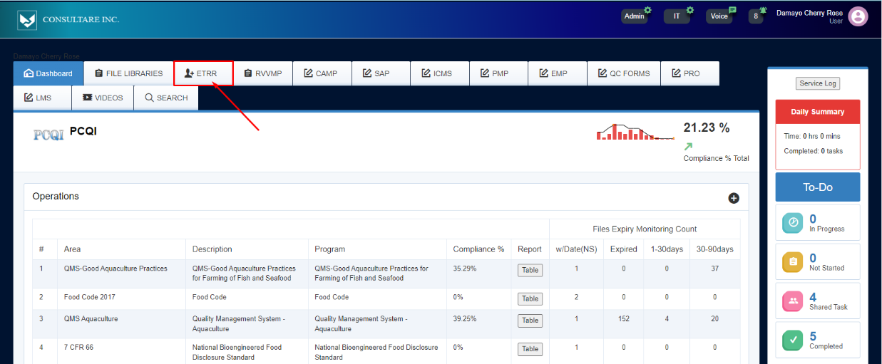
4.5.3.1.2. Choose the Employee Name you want to upload the records with.
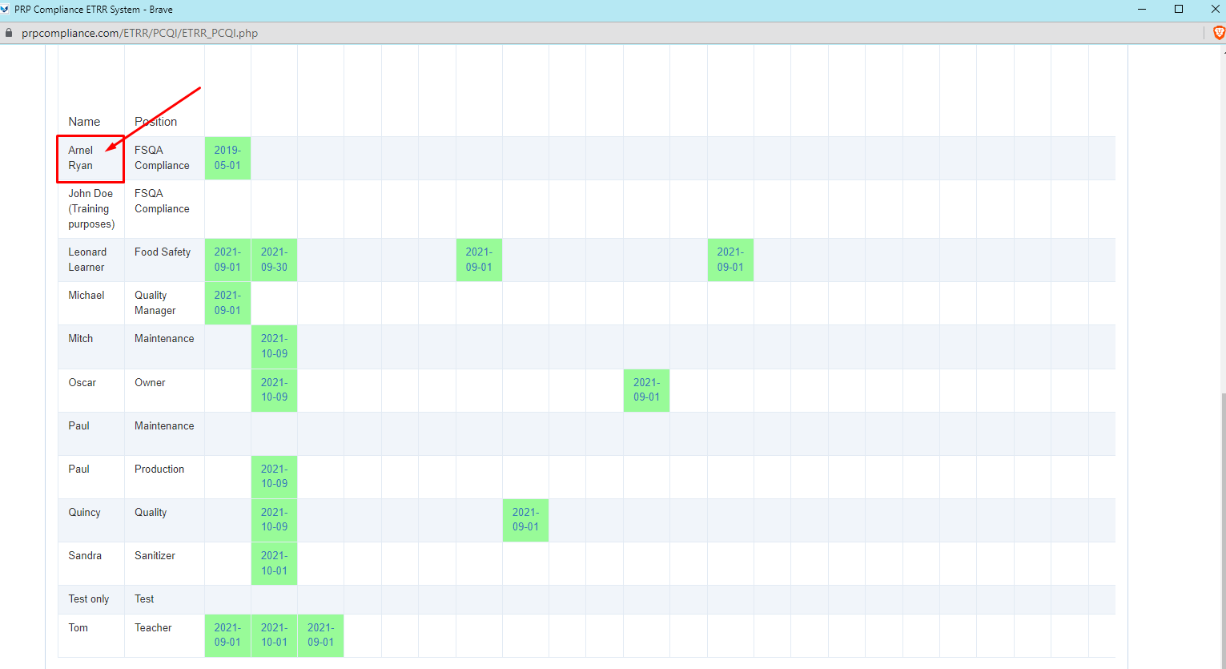
4.5.3.1.3. Identify if the record is a Training Records or an Employee Files, then upload it to the designated table.
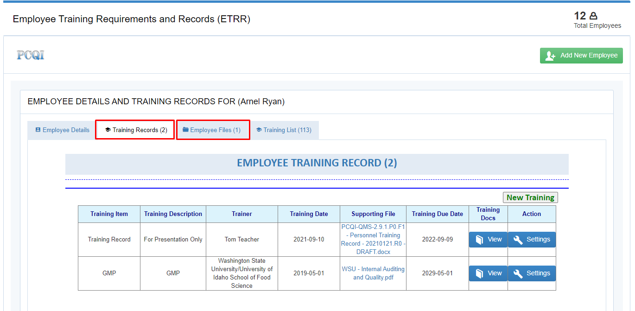
4.5.3.1.4. If it is a Training Records, select from the “Training List” table, and “Get Training”
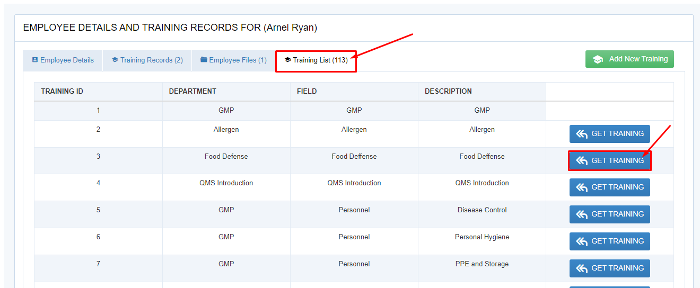
4.5.3.1.5. Then Click “OK”
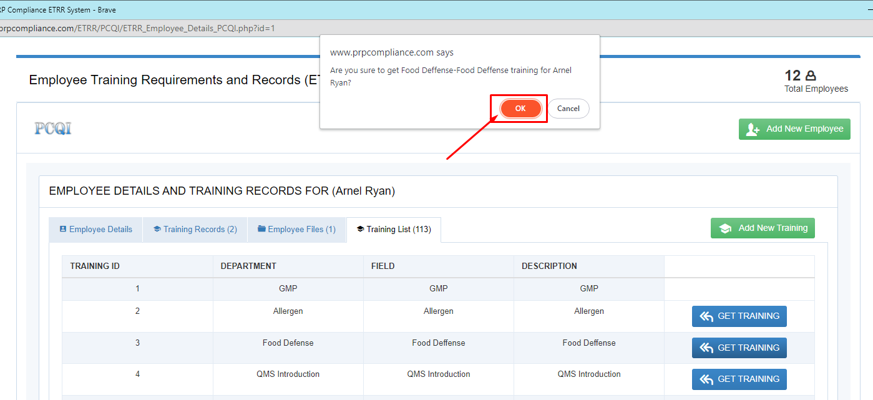
4.5.3.1.6. Go back to “Training Records”, and Click “Settings”
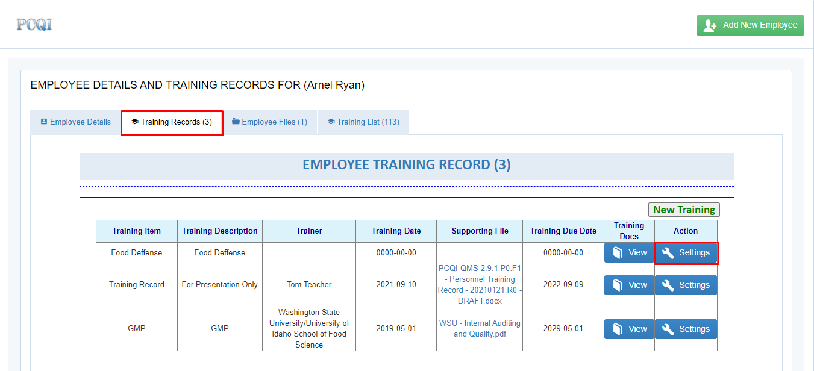
4.5.3.1.7. Fill out the Trainer, Training Date, and Training Due Date, then click “Save Changes”
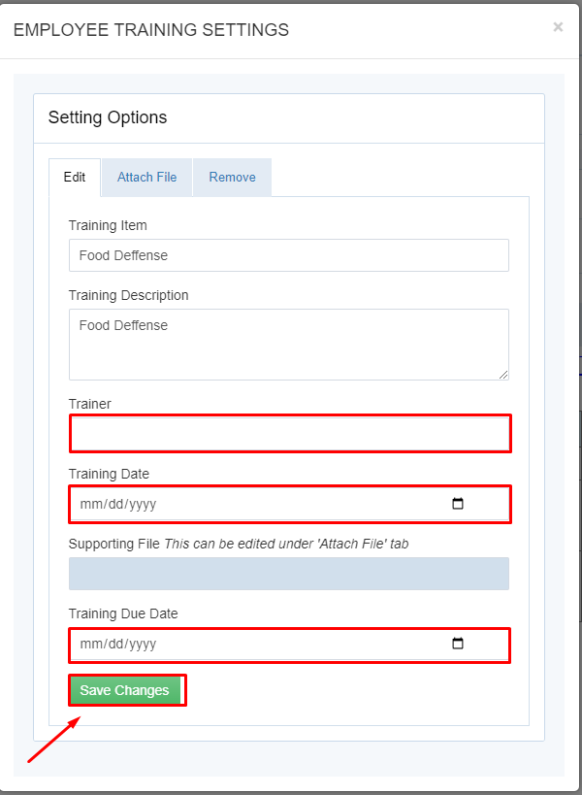

4.5.3.1.8. Click “Attach File” tab, choose the record you want to upload and click “Upload” button.

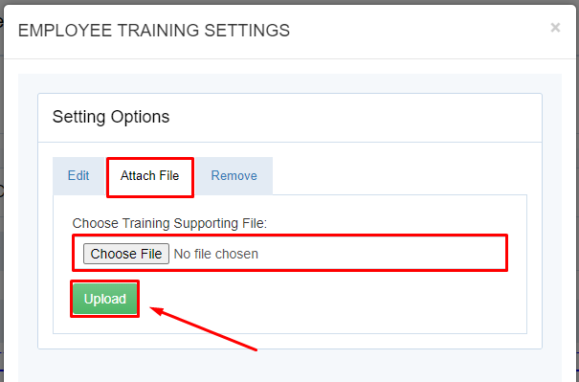
4.5.3.1.9. If it is Employee Files, click “Employee Files” tab, and click “Add File” button

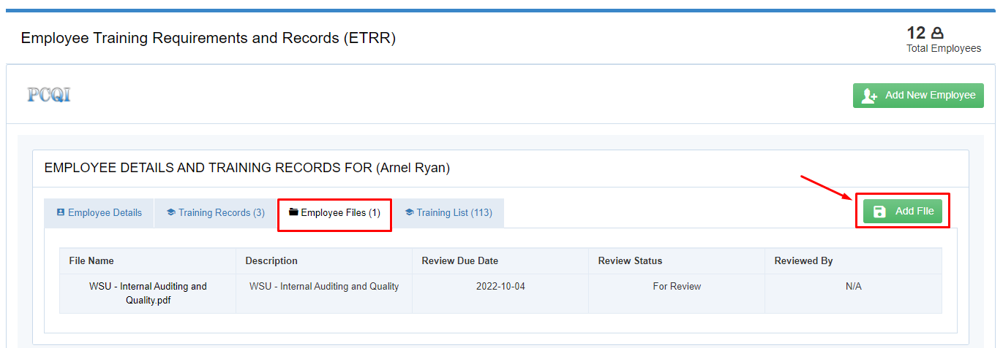
4.5.3.1.10. Click “Choose File” and add a “File Description” based on the record that you have, add a “Review Due” set annually, then click “ADD FILE”.
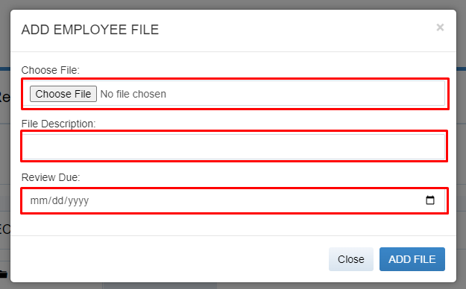
2.5.3.1.10.1. Example image below
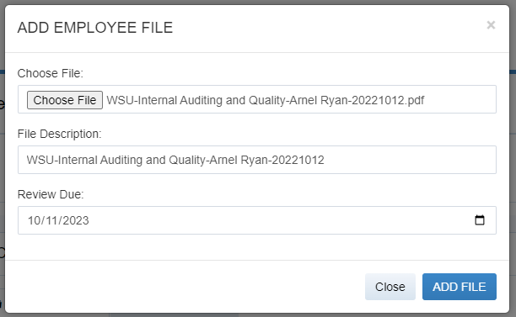
4.5.3.2. InterlinkIQ System
4.5.3.2.1. Login to InterlinkIQ System, and Click Employee Roster
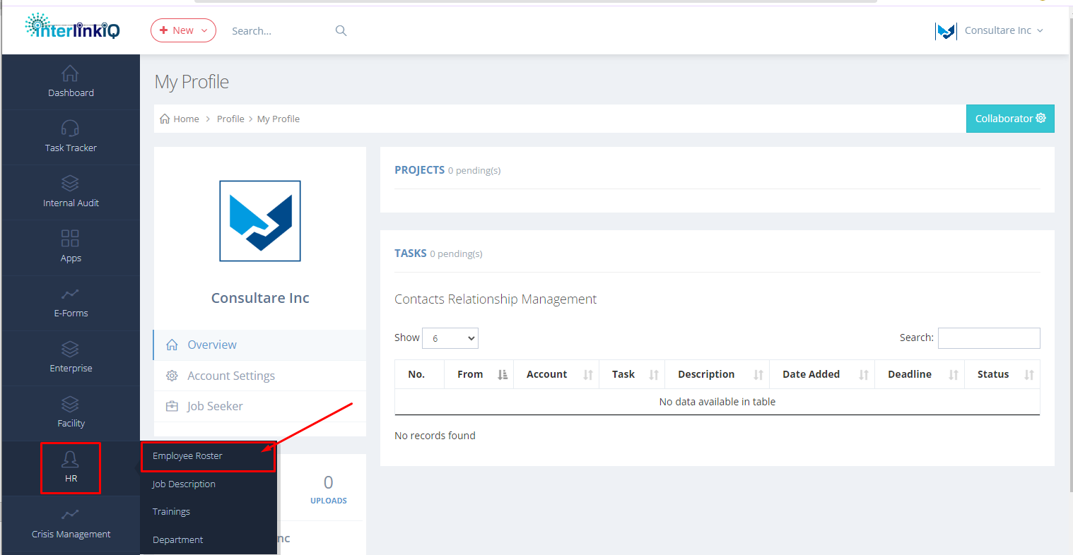
4.5.3.2.2. Choose the Employee Name you want to upload the records with, then click “View” button
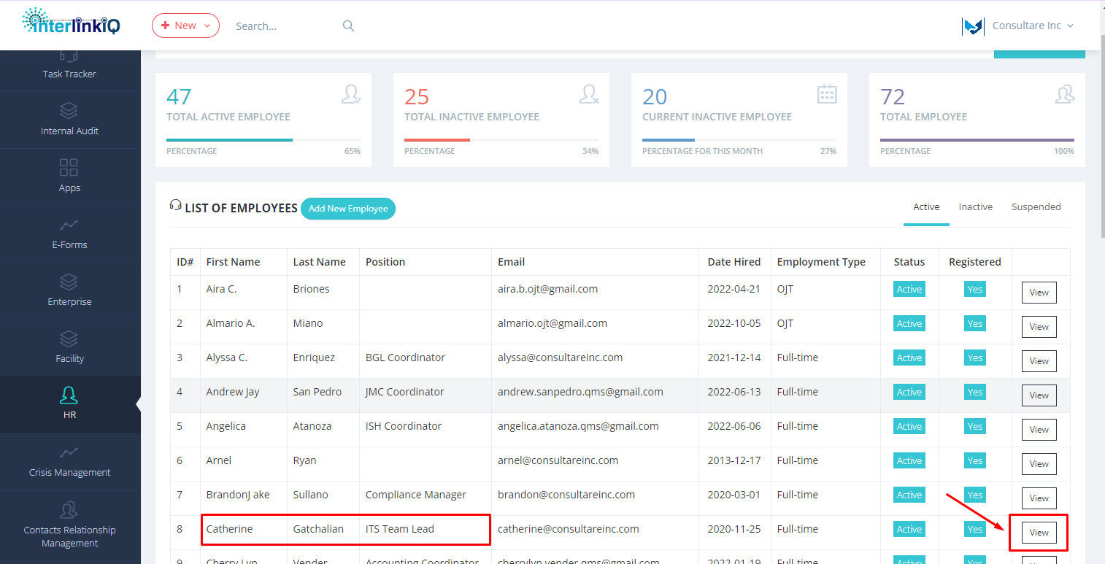
4.5.3.2.3. Identify if the record is a Training Records or an Employee Files.
4.5.3.2.3.1. Employee Files are uploaded in “Employee Files” tab, click on “Add New File” button.
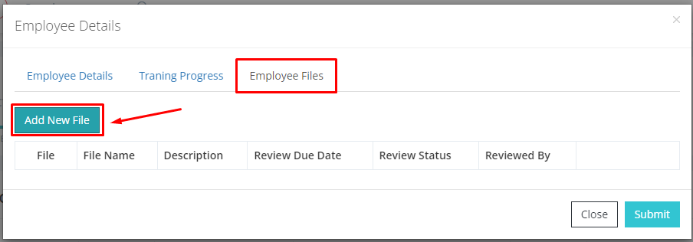
4.5.3.2.3.1.1. Click “Choose File” and add a “File Name and Description” based on the record that you have, update the “Review Due Date” set annually, then click “Submit” button.
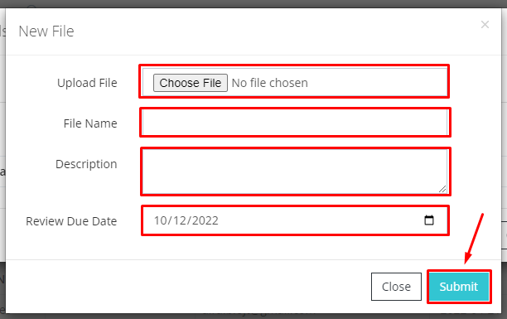

4.5.3.2.3.2. Training Records are uploaded in “Training Program” tab. Ongoing for development.
4.5.4. Records Retention
4.5.4.1. Records are kept for Three years following the date of hire
4.5.4.2. Personnel Records are archived after clearance and the last pay has been released.
4.5.4.3. Records are removed to the database after Five years the employee leaves the company.

4.6 Leave Policy

A Leave Policy describes the number of leaves of Consultare Inc. employee Virtual Assistants have, the type of leaves they are qualified, and how to apply for leaves. With this policy, the company guarantees you that we provide you the necessary time off to resolve any problems, recover from sickness, go for a vacation, deal with life events, celebrate holidays, or to simply relax.

4.6.1 Paid Time Off:

4.6.1.1. PTO is a combination of vacation, emergency, sick, and personal time for Virtual Assistants to use when they paid time off from duty.
4.6.1.2. A regular Virtual Assistant, either full- time or part-time can avail PTO for 24 days every year.
4.6.1.3. After the 90 days probationary period, new Virtual Assistant will start incurring of 2 days per month PTO.
4.6.1.4. Procedures:
4.6.1.4.1 A Virtual Assistant should inform the HR and his/ her Superior in
advanced for the date he or she wants to apply for.
4.6.1.4.2 The date a Virtual Assistant applied will be still under approval to avoid similar date of leave with your team alternate.
Types of PTO:

4.6.2 Vacation Leave
4.6.2.1 All full-time and part- time regular Virtual Assistants are eligible for vacation benefits.
4.6.2.2 All Virtual Assistants who are eligible for the Paid Time Off must submit a yearly vacation plan to their immediate head subject for approval.
4.6.2.3 For Vacation leave scheduled attached to Christmas Holiday and New Year’s Holiday, Virtual Assistant can only avail once every other year and subject for approval by immediate head.
4.6.2.4 Vacation Leave cannot be filed after sick leave.
4.6.2.5 A Vacation Leave is a planned leave for Birthdays, Anniversaries and Personal Reasons must be filed a minimum of 3 days before the leave.
4.6.2.5.1 The Virtual Assistant must seek approval thru email with project and task endorsement.
4.6.2.5.2 Approval of immediate head must be 3 days before the Vacation Leave.

4.6.3 Sick Leave
4.6.3.1 For scheduled sick time like operations and medical consultations, a Virtual Assistant should notify his or her Superior in advance or at least two (2) days before the date of leave.
4.6.3.2 A proper turnover to your alternate for your duties and responsibilities to avoid delays of work.
4.6.3.3 Sick days are deducted from your PTO days.
4.6.3.4 Sick leave of more than two days must present a medical certificate before going back to work.
4.6.3.5 Short notice or unscheduled call in for more than 6x occurrence in one year will be terminated.

4.6.4 Emergency Leave
4.6.4.1 For emergency leave, an Virtual Assistant must notify his or her supervisor immediately within 24 hours.
4.6.4.2 There should be a proper turnover to your alternate for your duties and responsibilities to avoid delays of perform.

4.6.5 Maternity Leave
4.6.5.1 Female Virtual Assistant shall file a Maternity Leave 30 days before her delivery due date and must ensure to endorsed all TO DO and deadline to colleagues. A Virtual Assistant can avail of a paid Maternity Leave regardless if normal or C-section delivery up to 45 days. During the first day up to 45 days, Virtual Assistant is not obliged to attend meetings and advice to rest. On the 45th day, the Virtual Assistant will start rendering at least 20 hours for the 1st week for re- orientation. After 45 days the Virtual Assistant shall report back to perform as full-time or 40 hours a week.
Days of Leave Classifications
Days of Leave | Classifications
30 days (4 weeks) | Advise to rest,
35-40 days (6th week) | Report to work at least 20 hours a week and start attending Team Meetings re-orientation.
40-45 days (7th week) | Report back to work as full-time work 40 hours a week.

4.3.5.2 All female personnel can avail of the maternity leave within the scope of this policy.

4.3.6 Paternity Leave

4.6.6.1 All male Virtual Assistants are eligible for this leave within the scope of this policy. The Virtual Assistant should notify his Superior in advance for the possible date of birth of his child.
4.6.6.2 Paternity leave must be acquired within 15 days of child birth. Maximum of seven (7) days for Paternity leave is only allowed.

4.6.7 Leave of Absence (applicable for Probationary Virtual Assistants)

4.6.7.1 Under special circumstances, full-time and part-time regular Virtual Assistants who have completed the 90 day probationary period maybe granted a leave of absence without pay. The granting of this type of leave is normally for compelling reasons and is dependent upon the written approval of your supervisor. Paid leaves of absences may be available in accordance with federal, state or local laws, as applicable. Non- Paid time off (PTO) Virtual Assistants may request at any time for a non- PTO. It should be deducted from the payroll period.
4.6.7.2 Leaves may not exceed 3 days during which time no benefits will accrue.
4.6.7.3 The following will be deemed a voluntary resignation for the purposes of a leave of absence:
4.6.7.3.1 failure to advise the Company of your availability to work;
4.6.7.3.2 obtaining another position;
4.6.7.3.3 engaging in another business;
4.6.7.3.4 failure to return to work when notified; or
4.6.7.3.5 your continued absence from work beyond the time approved by the Company.

4.6.8 Reporting Absences

4.6.8.1 To encourage reporting of absences (whether as vacation, sick leave, or otherwise), any absence without proper notice or excuse will be treated as an unpaid leave and subject to the section titled “ATTENDANCE AND PUNCTUALITY.” Reporting should be done preferably via Google forms and through email.
4.6.8.2 A Virtual Assistant who will not report to work and did not notify the immediate head or HR will be terminated within 72 hours due to abandonment of work.
4.6.8.3 Although a physician’s statement normally will not be requested for absences of less than three work days, the Company reserve the right to request such a statement upon the Virtual Assistant’s return to perform or at other times the Company deems appropriate.

PART 5: SALES AND MARKETING POLICY

5.1 Customer Service Representative Policy

PURPOSE
5.1.1.1. To properly address customers’ requests, concerns/complaints and inquiries and take corrective actions to satisfy customers’ expectations and requirements.
5.1.1.2. To ensure the standard engagement process with customers/clients, prospects and contacts are being followed.

    - SCOPE

      - The procedure covers the following:
        - Activities in handling customers’ requests, concerns/complaints and inquiries in relation to our company services (e.g., Project-based, System subscription, System with Support and with End to End Services subscription, etc.).
        - Cold-calling/emailing engagement procedures

POLICY

All Customer Service Representative/s are required to follow CSR standard procedures to provide the best possible services to our customers/clients, prospects and contacts; and to ensure the highest possible level of service and commitment of our company.

RESPONSIBILITIES
      - Customer Service Representative-Inbound - is responsible for handling and assisting customers’ requests, concerns/complaints and inquiries.
      - Customer Service Representative-Outbound - covers the cold-calling-emailing and scheduling of Demo Presentation Meeting/s.
      - Admin Support - is responsible for Bria Support, Data Mining/ Research/ Lead Generation and Database updates and monitoring.
      - CSR Team Leader - assists/trains CSR Inbound and Outbound (Call and Email) with CSR standard procedures.
      - CSR Coordinator - ensures all customers’ requests, concerns/complaints and inquiries, cold-calling and demo presentation meetings are completely processed within CSR standard procedures.
      - CSR Supervisor- responsible for review and approval of CSR’s response to any customers’ requests, concerns/complaints and inquiries.
      - CSR Manager – Overall training/monitoring of CSR Team. Assess GAP’s and action items for continuous improvement of the Team.

PROCEDURE
      - All updates in related to CSR activities must be inputted daily at Contact Relationship Management (CRM) section at www.interlinkiq.com (watch CRM instructional video for reference).
      - Outbound/Prospects Daily Target
        - Call – every CSR must have the following leads/prospects daily according to their status.
        - 2 weeks – 20 prospects
        - 4 weeks – 30 prospects
        - 6 weeks – 35 prospects
        - 8 weeks – 45 prospects
        - 12 weeks and up– 50 prospects
      - Email/campaign – every CSR must have the following leads/prospects daily according to their status.
        - 2 weeks – 20 prospects
        - 4 weeks – 30 prospects
        - 6 weeks – 35 prospects
        - 8 weeks – 45 prospects
        - 12 weeks and up– 50 prospects

Note: CSR leads/prospects daily target for outbound call and email/campaign will vary if there’s any task or urgent request/discussion from senior management; any software/portal (CMS) issues to be fixed or any on-going development of software or application system.

    - In handling customer requests, inquiries and concerns/complaints, customer service representative must do the following:
      - Acknowledge/Respond to the requests, inquiries and concerns/complaints.
      - Inbound – Call
        - Answer the call within 10-15 seconds.
        - Answer the caller with respect and courtesy.
        - Use positive expressions/script words (use approved call script only provided by the Team Leader).
        - Prohibits the use of offending words.
      - Inbound – email of requests, inquiries and concerns/complaints.
        - Acknowledge the email within 24 business hours.
        - Reply with respect and courtesy.
        - Use positive expressions/script words (use approved call script only provided by the Team Leader).
        - Prohibits the use of offending words.
    - Receiving of Customers' requests, inquiries and concerns/complaints.
      - Receive the Customer's requests, inquiries and concerns/complaints and inform the concerned department/ division/section.
    - Inform customer of progress of the requests, inquiries and concerns/complaints.
      - Email/call the inquirer/contact person every progress/status of requests, inquiries and concerns/complaints.
      - Reply with respect and courtesy.
      - Use positive expressions/script words (use approved call script only provided by the Team Leader)
      - Prohibits the use of offending words.

    - Inform customer on completion of the requests, inquiries and concerns/complaints
      - Inbound – call of requests, inquiries and concerns/complaints
      - Email/call the inquirer/contact person once the requests, inquiries and concerns/complaints are completed.
      - Reply with respect and courtesy.
      - Use positive expressions/script words (use approved call script only provided by the Team Leader).
      - Prohibits the use of offending words.

5.2 Social Media Coordinator

PURPOSE
      - To ensure the standard engagement process with customers/clients, prospects and contacts are being followed by Social Media Coordinator.

    - SCOPE
      - The procedure covers the following:
        - Activities in handling prospects and contacts’ inquiries in relation to our company services (e.g., Project-based, System subscription, System with Support and with End to End Services subscription, etc.) by the Social Media Coordinator.

POLICY

5.2.3.1 Social Media Coordinator is required to follow standard procedures to provide the best possible services to our prospects and contacts; and to ensure the highest possible level of service and commitment of our company.

RESPONSIBILITIES
      - Social Media Coordinator - is responsible for handling and assisting prospects and contacts’ requests, concerns/complaints and inquiries.
      - Social Media Team Leader - assists/trains SocMed Coordinator with Sales and Marketing standard procedures.
      - Social Media Coordinator - ensures all prospects and contacts’ requests, concerns/complaints and inquiries, cold-calling and demo presentation meetings are completely processed within Sales and Marketing standard procedures.
      - Social Media Coordinator Supervisor- responsible for review and approval of SocMed Coordinator response to any customers’ requests, concerns/complaints and inquiries.
      - Social Media Coordinator Manager – Overall training/monitoring of SocMed Coordinator.
      - Assess GAP’s and action items for continuous improvement of the Team.

PROCEDURE
      - All updates in related to SocMed activities must be inputted daily at Contact Relationship Management (CRM) section at www.interlinkiq.com.
      - In handling customer requests, inquiries and concerns/complaints, Social Media Coordinator representative must do the following:
      - Acknowledge/Respond to the requests, inquiries and concerns/complaints.
        - Inbound – email of requests, inquiries and concerns/complaints.
          - Acknowledge the email within 24 business hours.
          - Reply with respect and courtesy.
          - Use positive expressions/script words.
          - Prohibits the use of offending words.
      - Receiving of Customers' requests, inquiries and concerns/complaints.
        - Receive the Customer's requests, inquiries and concerns/complaints and inform the concerned department/ division/section.
      - Inform customer of progress of the requests, inquiries and concerns/complaints.
        - Email/call the inquirer/contact person every progress/status of requests, inquiries and concerns/complaints.
        - Reply with respect and courtesy.
        - Use positive expressions/script words
        - Prohibits the use of offending words.
      - Inform customer on completion of the requests, inquiries and concerns/complaints
        - Inbound – call of requests, inquiries and concerns/complaints.
        - Email/call the inquirer/contact person once the requests, inquiries and concerns/complaints are completed.
        - Reply with respect and courtesy.
        - Use positive expressions/script words.
        - Prohibits the use of offending words.

6.1. Employment Terms

PART 6: ON-THE-JOB Training

6.1.1. Employment Applications

6.1.1.1. The company depends on the accuracy of information through employment application and the data provided by the candidates during the hiring process thus, any falsifications or misrepresentations may result in prohibiting the candidate from entering the company. If the candidate has been employed, termination of employment may be considered.

6.1.2. Types of On-The-Job Trainees

6.1.2.1. OJT / Intern under the OJT Program

6.1.2.1.1. Perform hours are based on their scheduled time, Monday to Friday.

6.1.2.2. OJT under the OJT Crossover/Part-time Position

6.1.2.2.1. Performs at least 4-8 hours a day or 20-30 hours per week, Monday to Friday.

6.1.3. Recruitment

6.1.3.1. The recruitment team gathers OJT applicants by sending an email request for an Internship to Schools.

6.1.3.2. OJT Application emails are reviewed and collected.

6.1.3.3. A Demo presentation to Schools will be conducted based on request.

6.1.3.4. HR will send an email to the school coordinator for the form to be filled out by the OJT.

6.1.3.6. Qualified OJT applicants who will proceed to the OJT Program will receive the following emails:

6.1.3.6.1. OJT Getting Started

6.1.3.6.2. Once the HR department received the OJT Details from the OJT Applicant, they will send the OJT - Onboarding Training email invitation.

6.1.4. Types of OJT Training Plan – InterlinkIQ Training

6.1.4.1. Onboarding OJT / Intern - Training Category Type

6.1.4.1.1. Training topics are Company Onboarding, Service Log Training (My PRO), Email Etiquette, Document Control, InterlinkIQ Dashboard Navigation, and PCQI Conversion.

6.1.4.2. Onboarding OJT Crossover - Training Category Type

6.1.4.1.1. Training topics are Company Onboarding, Service Log Training (My PRO), Account Specific PF Bundle Customization, Drafting, and Updating files, Email Management, Uploading of Documents to InterlinkIQ Dashboard.

6.1.5. Training records

6.1.5.1. Comprehension Quiz records are collected and uploaded to Interlink Employee Files.

6.1.6. Trainee

6.1.6.1. Evaluation – they will be evaluated based on performance and output on their assigned Account when they reach 250 hours.

6.1.6.2. Retraining – they will be re-train on some topics that need improvement.

6.1.7. Attendance and Punctuality
6.1.7.1. Attendance and punctuality are important factors for your success within our Company. We perform as a team, and this requires that each person is in the right place at the right time.
6.1.7.1.1. OJT / Intern will Login to OJT Main Virtual Office and to the assigned department office.
6.1.7.1.2. OJT Crossover will Login to VA Main Virtual Office 1 or VO 1 and to the assigned department office.
6.1.7.2. If you are going to be late for performance or absent, notify your supervisor and copy hr@consultarein.com as far in advance as is feasible under the circumstances, but before the start of your workday.
6.1.7.3. Personal issues requiring time away from your performance, such as doctor’s appointments or other matters, should be scheduled during your non-performing hours if possible.
6.1.7.4. If you are absent for three consecutive days without notifying the Company, it is assumed that you have voluntarily abandoned your position with the Company, and you will be removed from the OJT Program.
6.1.7.5. Consultare Inc. regular performance schedule:
6.1.7.5.1. Any changes in the schedule are subject to approval by the immediate head.

PART 7: Notice to Explain

7.1 Definition of Terms:

7.1.1 NTE – Notice to Explain is a document issued to any Virtual Assistance who violated the company policy, rules and procedures.
7.1.2 Incident Report – a document issued reporting the events, documenting the facts related to the incident in the workplace.
7.2 Issuance of NTE
7.2.1 A incident who violated the company policy rules and procedures.
 | 1st Offence | 2nd Offence | 3rd Offence | 4th Offence | 5th Offence
Verbal Warning from Immediate Head
Verbal Warning from HR personnel
Written Warning with IR – NTE 1
Written Warning with IR – NTE 2
NTE 3 – Notice of Termination

7.2.2 An NTE 1 will be issued to a Virtual Assistant with supporting incident report and factual evidence.
7.2.2.1 The Virtual Assistant will be given 24 hours to explain and to present her factual evidence to prove otherwise the NTE issued.
7.2.2.2 Once respond is received and proof of violation is presented the Virtual Assistant is forfeited to receive any tenure ship, bonuses and incentives with 6 months period.
7.2.2.3 The Virtual Assistant will undergo a re-training and evaluation for 15 days and will be called for counseling by the HR.

7.2.3 An NTE 2 will issued to a Virtual assistance after issuance of NTE 1 within 1 year calendar period.
7.2.3.1 The Virtual Assistant will be given 24 hours to explain and to present her factual evidence to prove otherwise the NTE issued.
7.2.3.2 Once respond is received and proof of violation is presented the Virtual Assistant is forfeited to receive any tenure ship, promotion, bonuses and incentives within 1 year period.
7.2.3.3 The Virtual Assistant will undergo a re-training and evaluation for 15 days and will be called for counseling by the HR.

7.2.4 An NTE 3 will issued to a Virtual assistance after issuance of NTE within 1 fiscal year period.
7.2.4.1 The Virtual Assistant will be given 24 hours to explain and to present her factual evidence to prove otherwise the NTE issued.
7.2.4.2 Once respond is received and proof of violation is presented the Virtual Assistant is terminated to all his company access and will be issued a Notice of Termination.

7.2.5 A Virtual Assistant who have been issued an NTE 1, NTE 2 and NTE 3 will reset every fiscal year.
7.2.5.1 An NTE will be cleared within 1 year from issuance of the last NTE date.
Example:
NTE 1 - issued January 5, 2022
NTE 2 – issued December 26, 2022
Clearance – December 27, 2022

7.3 Abandonment of duties and responsibilities within 72 hours will automatically be terminated and tagged as AWOL – absence without leave.

PART 8: Accounting Procedures

  - Sales Invoicing
    - Invoicing Policy
      - This sets out the processes for the issue, payment, and retention of invoices. It also states the legal requirements for the content of the invoices.
    - Issuing of Invoices
      - Consultare Inc issue invoices monthly normally every end of the month. The invoices are always charged for the full amount based on their signed Subscription Agreement. Also, if there is an agreement between the customer confirming a specific agreement in advance of invoicing.
        - Below is the sample Subscription Agreement for reference.
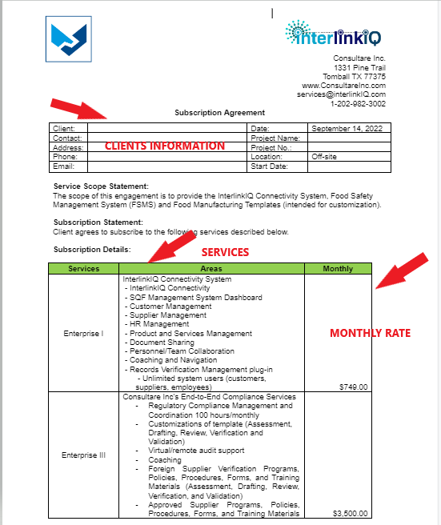
    - Invoice Content
      - The invoice will be issued to the finance department of the clients according to Consultare’s Inc invoice template which will contain the following information:
        - Consultare’s logo, business name, address, and contact details. (See number 1)
        - Unique Invoice number assigned to client, that way we can easily track the invoices that are issued to client. (See number 2)
        - The date of the invoice. (See number 3)
        - Below the Consultare’s details is the client’s information. (The name and address of the client for which the invoice is being issued. (See number 4)
        - Itemized list of the services provided to client. (This includes the brief description of each service, the quantity supplied, or hours worked, and the rate for the service. (See number 5 and 6)
        - Invoice total amount owed. (Individual item costs should be detailed, as well as applicable taxes, discounts, and prepayments.) (See number 6)
        - Payment terms. (Includes the payment methods Consultare’s accept (i.e., cash, check, credit card, etc.) and any late fees that charge on overdue invoices. (See number 7)
        - Payment due date. (Clearly list the deadline for payment on the service invoice but sometimes it depends on the agreement of the two parties.
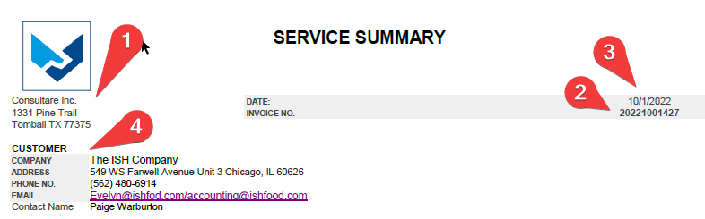
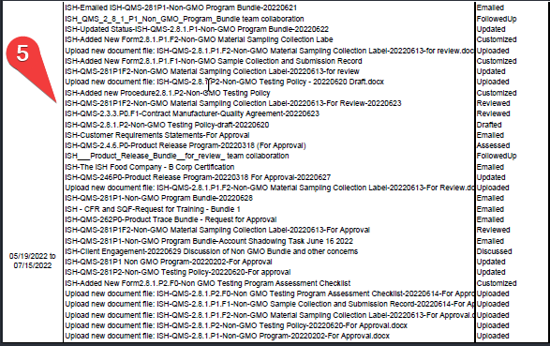

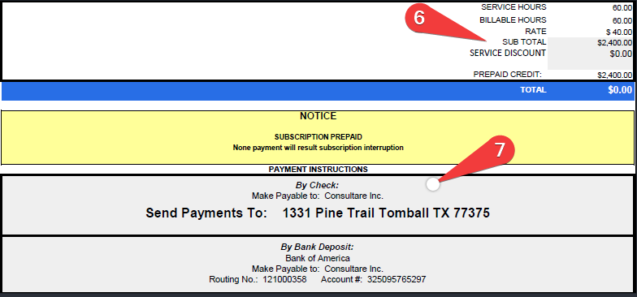

    - Credit Control and The Collection of Debts
      - The Accounting Coordinator is responsible for ensuring that:
        - Invoices are issued stating that our terms of business are strictly 30 days from the date of the invoice.
        - Invoices are raised for the whole sum due.
        - If payment has not yet been made after two weeks of issuance of invoice, we can send a polite email regarding the invoice or check if they even received the bill.
        - If payment has not been made after 30 days of invoice a statement is sent out by the Accounting Officer to the Customer’s Finance Contact.
        - If payment has not been made after 60 days the CFO authorizes a second statement to be sent to the Clients Finance Contact by the Accounting Officer, with a follow up telephone call to those customers with a poor payment history.
        - Accounting Officer issue a work stoppage due to non-payment and/or unsettled invoices. Services will have resumed once all outstanding invoices have been paid.

    - How to generate service logs for PRP Dashboard
      - Procedure on how to generate service logs
        - PRP Dashboard
          - Login to PRP System and click this link
https://www.prpcompliance.com/SERVICES_LOGS/SERVICE_REPORT_GENERATE_INVOICE.php?filter=Button_
8.1.5.1.1.2 This will be the screen that will pop out once you click the above link.
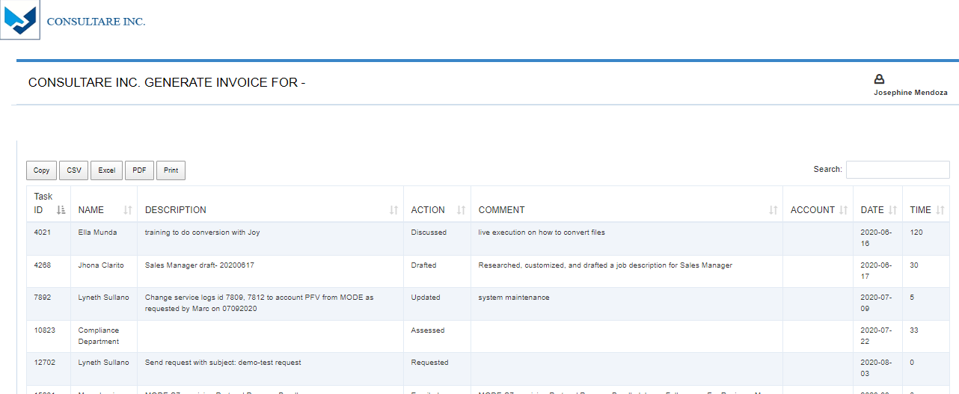
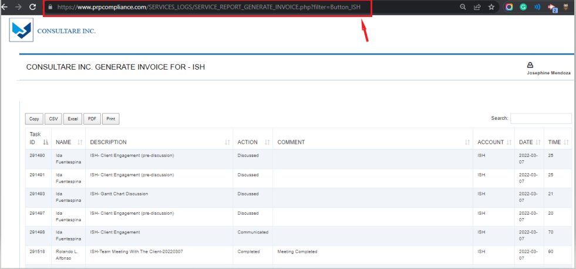
          - On the address bar change the client’s name on the end of the web address then hit Enter.

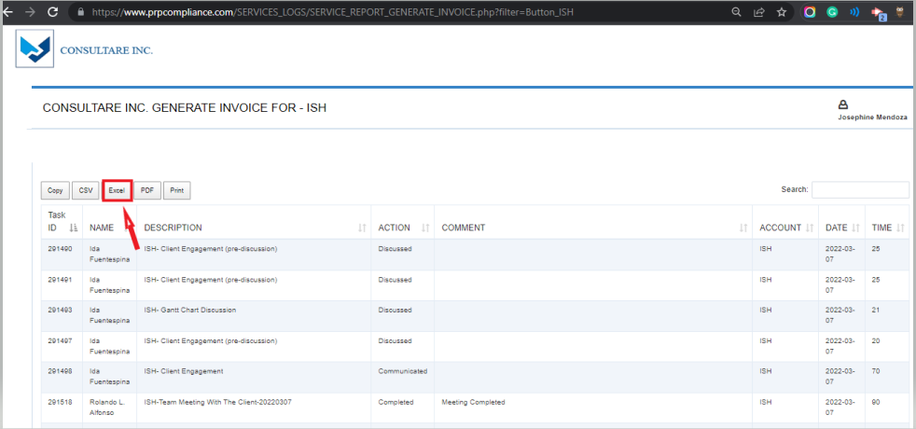
          - Click the EXCEL button to generate service logs for that specific client.

8.1.5.1.1.5 Then Click the file on the specific folder then SAVE.
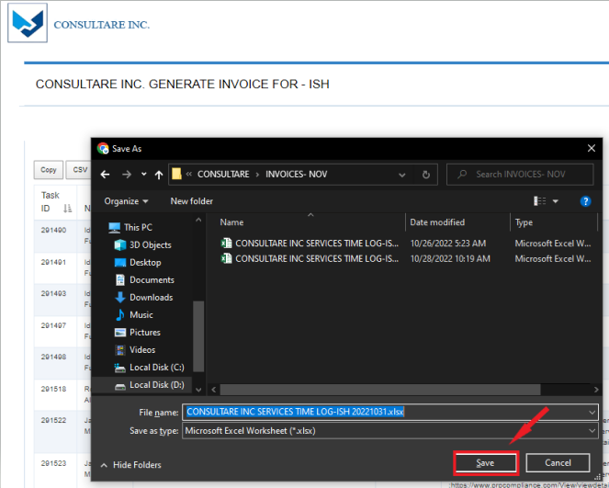

          - Open the file from the specific folder.
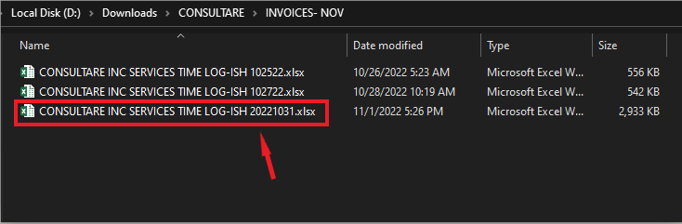
          - Once opened this will be the format of the service logs generated from the dashboard.

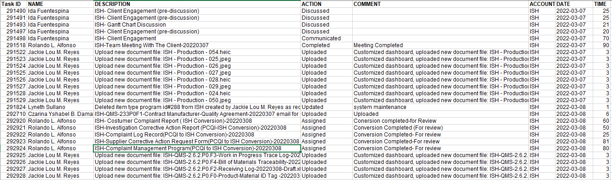
          - Sort out the date from A-Z then click OK.
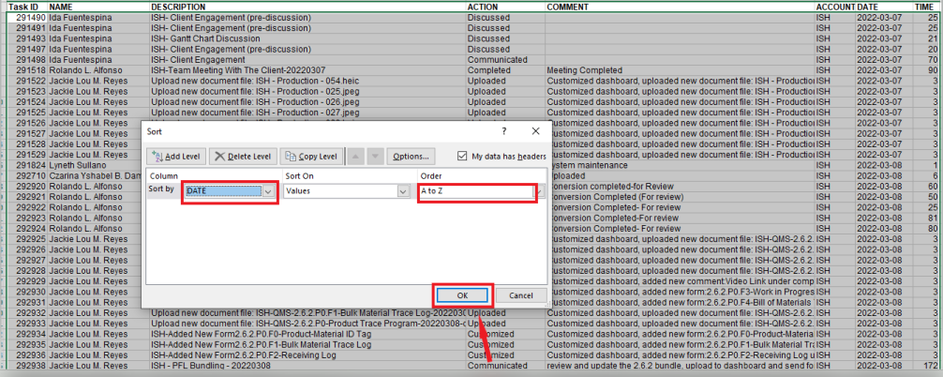

      - Once done sorting out the date check the Description, Action item, comments
        - Account and service time. Check if the Description is in the proper format of uploading a lesson
        - Below is the proper format on uploading a lesson.
        - Format: Company Initials-QMS-Code#.P# (P, F, L, SWS, WI)-Title-Date-Revision#

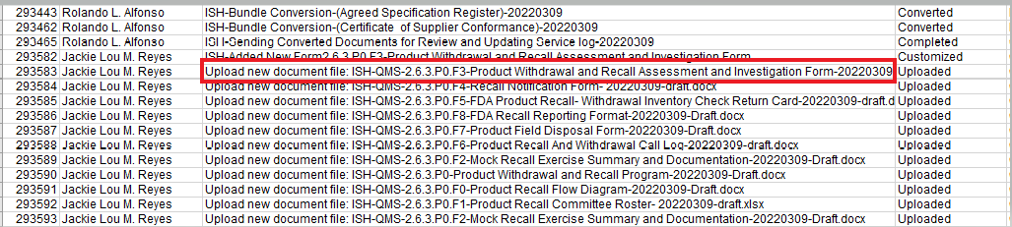

      - Then you’re done generating service logs from the dashboard. You can now start generating your Invoice.

    - Accounting Records Management
      - All records are stored to the InterlinkIQ System.
        - Invoices, Subscription Agreement, Payment from Clients etc. are uploaded to the Customer Tab on InterlinkIQ System.
      - Retention
        - Records are kept for one year following the start of their subscription agreement.
        - Records are kept on our database Interlink IQ System.
        - Records are removed on our database once the client cancelled their subscription.
      - Preservation
        - All records are preserved on the database with a backup.

    - Security
      - Only assigned personnel can access the records that are uploaded on the Interlink IQ System.
      - Only authorized personnel can access the database of records.
    - Frequency
      - Every week or as requested by the coordinator.
      - When there are changes from the data generated or by the coordinator.
    - Checking the accuracy of logs procedure.
      - Separate data from analysis and make analysis repeatable.
      - Check data against another source.
      - Document your process.
      - Get feedback from others.

PART 9: RECEIPT OF EMPLOYEE HANDBOOK AND

EMPLOYMENT- AT- WILL STATEMENT

PART 9: RECEIPT OF EMPLOYEE HANDBOOK AND

EMPLOYMENT- AT- WILL STATEMENT

PART 9: RECEIPT OF EMPLOYEE HANDBOOK AND

EMPLOYMENT- AT- WILL STATEMENT

PART 9: RECEIPT OF EMPLOYEE HANDBOOK AND

EMPLOYMENT- AT- WILL STATEMENT

PART 9: RECEIPT OF EMPLOYEE HANDBOOK AND

EMPLOYMENT- AT- WILL STATEMENT

PART 9: RECEIPT OF EMPLOYEE HANDBOOK AND

EMPLOYMENT- AT- WILL STATEMENT

PART 9: RECEIPT OF EMPLOYEE HANDBOOK AND

EMPLOYMENT- AT- WILL STATEMENT

PART 9: RECEIPT OF EMPLOYEE HANDBOOK AND

EMPLOYMENT- AT- WILL STATEMENT

This is to acknowledge that I have received and read a copy of the CONSULTARE INC. Virtual Assistant Handbook and I understand that it contains information about the employment policies and practices of the Company. I agree to read and comply with all policies in this Virtual Assistant Handbook. I am not aware of any suspected or actual policy violations, other than any that have already been reported in accordance with the procedures set forth in this handbook and will immediately report any suspected or actual violations of which I become aware to my supervisor. However, if the complaint involves my supervisor or if for any reason I do not wish to bring the compliant to my supervisor’s attention, I shall present the information to HR and Senior Management. I understand that if the Company determines a staff member has violated a policy or fails to report a violation, appropriate disciplinary measures will be taken, up to and including immediate termination. I understand that the policies outlined in this Virtual Assistant Handbook are management guidelines only, which will require changes from time to time. I understand that the Company retains the right to make decisions involving employment as needed in order to conduct its work in a manner that is beneficial to the Virtual Assistants and the Company. I understand that this Virtual Assistant Handbook supersedes and replaces any and all prior Virtual Assistant Handbooks and any inconsistent verbal or written policy statements.

I understand that this Virtual Assistant Handbook supersedes and replaces any and all prior Virtual Assistant Handbooks and any inconsistent verbal or written policy statements.

I understand that except for the policy of at-will employment, which can only be changed by the CEO in a signed written contract, the Company reserves the right to revise, delete and add to the provisions of this Virtual Assistant Handbook at any time without further notice. All such revisions, deletions, or additions to the Virtual Assistant Handbook will be in writing and will be signed by the CEO. I understand that no oral statements or representations can change the provisions of this Virtual Assistant Handbook.

I understand that this Virtual Assistant Handbook is not intended to create contractual obligations with respect to any matters it covers and that the Virtual Assistant Handbook does not create a contract guaranteeing that I will be employed for any specific time period.

I understand that CONSULTARE INC., having a registered place of business in the United States of America, and the Virtual Assistant, having a registered in the Philippines, hereinafter, respectively, and collectively “the Parties.”

WHEREAS, the Company is engaged in consulting, policy, procedure, and training material development for US and International companies [the “Products”].

WHEREAS, the Company is actively seeking a Virtual Assistant to assist company in all aspects of business and service development for its products and services and general administrative services [the “Services”].

WHEREAS, Virtual Assistant has the ability to provide such services to assist Company in developing its products and provide services for Company and its clients virtually.

WHEREAS, the purpose of this Agreement is to engage Virtual Assistant provide such services to Company.

I understand that the Virtual Assistant shall provide Services as an assistant performing virtually for Company and its clients. Virtual Assistant agrees to serve in such capacity and to do and perform the services and acts, necessary to carry out the duties assigned by Company.

THIS COMPANY IS AN AT-WILL EMPLOYER. THIS MEANS THAT REGARDLESS OF ANY PROVISION IN THIS EMPLOYEE VIRTUAL ASSISTANT HANDBOOK, THE COMPANY OR I MAY TERMINATE THE EMPLOYMENT RELATIONSHIP AT ANY TIME, FOR ANY REASON, WITH OR WITHOUT CAUSE OR NOTICE. NOTHING IN THIS EMPLOYEE VIRTUAL ASSISTANT HANDBOOK OR IN ANY DOCUMENT OR STATEMENT, WRITTEN OR ORAL, SHALL LIMIT THE RIGHT TO TERMINATE THE EMPLOYMENT CONTRACT AT WILL. NO OFFICER, EMPLOYEE VIRTUAL ASSISTANT, OR REPRESENTATIVE OF THE COMPANY IS AUTHORIZED TO ENTER INTO AN AGREEMENT—EXPRESS OR IMPLIED—WITH ME OR ANY EMPLOYEE VIRTUAL ASSISTANT FOR EMPLOYMENT FOR A SPECIFIED PERIOD OF TIME UNLESS SUCH AN AGREEMENT IS IN A WRITTEN CONTRACT SIGNED BY THE CEO OF THE COMPANY. AS PART OF THIS AT-WILL POLICY, I UNDERSTAND THAT THE COMPANY EXPRESSLY RESERVES ITS INHERENT AUTHORITY TO MANAGE AND CONTROL THE BUSINESS ENTERPRISE AND TO EXERCISE ITS SOLE DISCRETION TO DETERMINE ALL ISSUES PERTAINING TO MY EMPLOYMENT, INCLUDING ALL MATTERS PERTAINING TO PROMOTION, JOB ASSIGNMENT, DEMOTION, TRANSFER, AND DISCIPLINE.

I understand that this Virtual Assistant Handbook refers to current benefit plans maintained by the Company and that I must refer to the actual plan documents and summary plan descriptions as these documents are controlling.

If I have questions regarding the content or interpretation of this Virtual Assistant Handbook, I will ask my supervisor or a member of management. By signing below, I acknowledged and accept:

